
March Offers
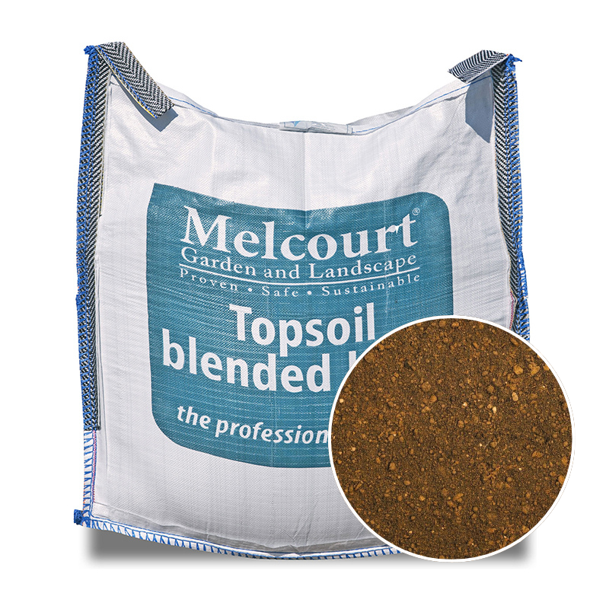

Topsoil Blended
Bulk Bag
Topsoil Blended Loam is a carefully manufactured, high-quality soil, consisting of sandy loam and organic matter.
£72.00

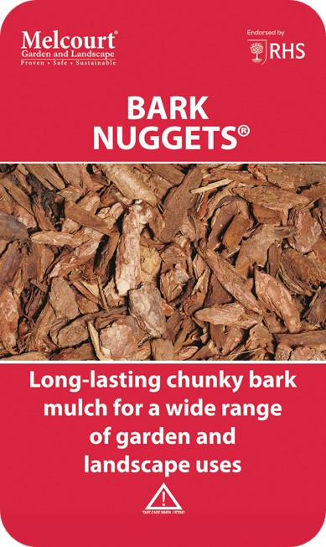

BARK BULK BAG
A long lasting, versatile, high-performance mulch, suitable for a wide range of professional and domestic landscape applications, including prestigious sites. Particularly effective when a high quality, decorative finish is required.
£78.00
Including VAT

