
March Offers
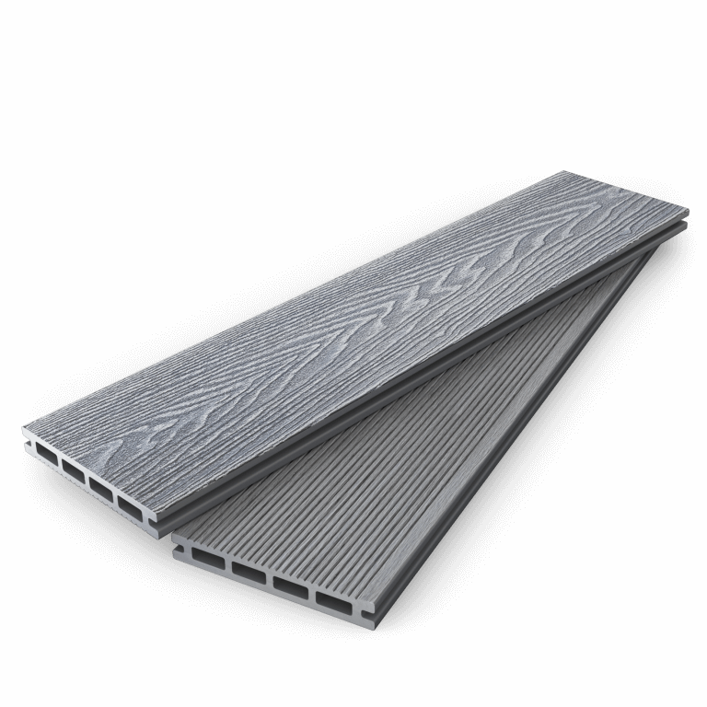

COMPOSITE DECKING SLATE 3.6m
£23.99eeach

eac

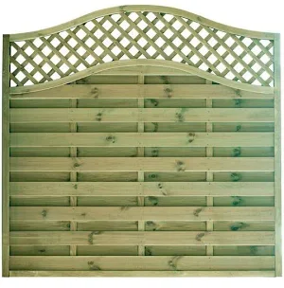
OASIS
Fence Panels
6’x6’ £59.99
6’x4’ £53.99
Including VAT

