
March Offers
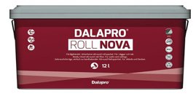

Dalapro Roll Nova
New formula – improved product qualities.
• High and stable quality.
• Good filling capability.
• Smooth consistency.
• Roller filler saves time.
• Gentle on the back and shoulders.
• Suitable for joint filling on plasterboard.
£36.00
Including VAT

