
March Offers

Multi-Purpose Compost
Bulk Bag
£90.00
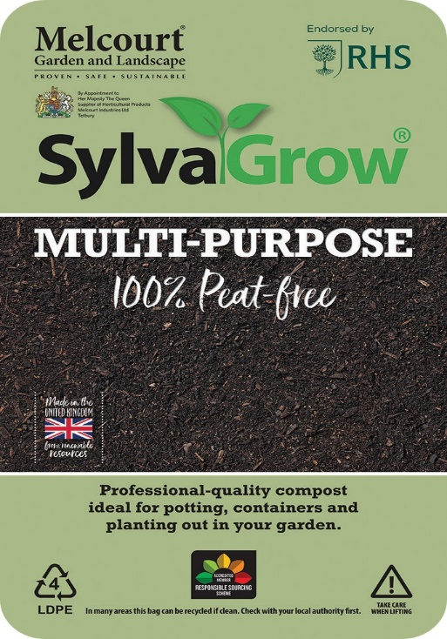

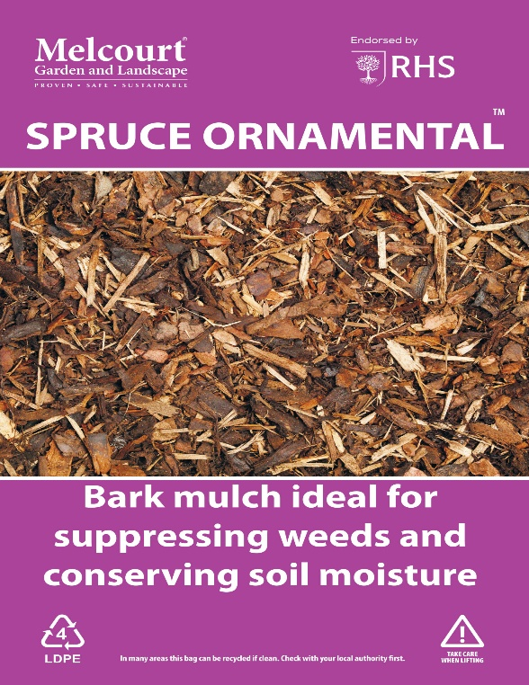
SPRUCE BARK
A long lasting, versatile, high-performance mulch, suitable for a wide range of professional and domestic landscape applications, including prestigious sites. Particularly effective when a high quality, decorative finish is required.
60ltr Bag
Buy 2 get 3rd Half Price
2 @ £8.00 each
1 @ £4.00 each

Including VAT

